|  |
| --- |
| Reversible Computation |
| User Manual |
| V2 |

|  |
| --- |
|  |

Table of Contents

Sprint 1 Features 1

Create Account 1

Login 2

Sprint 2 Features 2

View Profile 2

Edit Profile Information 3

Change first/last name 4

Change email address 4

Change password 5

Change description/age/location 5

Access Events 5

View Posts 6

Search Posts/Publications 6

View Popular Posts / Profiles 6

File Upload 7

# Sprint 1 Features

## Create Account

To create an account, click on the ‘Get Started’ button in the center of the index page

You’ll be redirected to the registration page

Enter your desired account details in the input boxes and ensure the details are valid

Enter a valid email address:

* Must include an ‘@’ symbol
* Must include a domain name
* Mustn’t include invalid characters

Then click the ‘Register’ button, the page will be refreshed  
And a message will appear if your registration was successful.

## Login

To access the login page  
  
Click on the ‘Already got an account’ prompt on the register page

You’ll be redirected to the login page

Enter your email and password you created when registering and click the ‘Login button’

After logging in, you’ll be redirected to the homepage

# Sprint 2 Features

## View Profile

To view your profile, hover over the Profile icon and select ‘Profile’

This is the Profile page

You can view basic details about your account

Name includes both your first name and last name

The ‘Edit Profile’ button redirects you to the Edit Profile page where you can edit the details shown on this page.

## Graphical user interface, text, application Description automatically generatedEdit Profile Information

To edit profile information, hover over the ‘Profile’ icon in the top right of the page

A dropdown menu will appear, click ‘Edit Information’

You’ll be redirected to the ‘Edit Information’ page

### Change first/last name

Enter your new first/last name in the corresponding input boxes and click on the button

The page will be refreshed, and your details will be updated

### Change email address

Enter a valid email address:

* Must include an ‘@’ symbol
* Must include a domain name
* Mustn’t include invalid characters

Click change email address. The page is refreshed, your email is updated, and your previous email address now has no association to your account.

This means, to log in, you’ll have to use your new email address.

### Graphical user interface Description automatically generatedChange password

Enter your new password and click ‘change password’

Once your new password is successfully updated, you’re logged out and redirected to the login page.

To access your account, you now have to enter your new password, and you’ll be redirected to the page you last tried to access.

### Change description/age/location

Description is a brief description about yourself

Age and Location are self explanatory

All three of these inputs are optional and if you do update any of these, they will be displayed on your profile page

## Access Events

To access the events page, find the Events option in the top center of the page (navigation bar)

This is the events page.

### Graphical user interface, text, application, email Description automatically generatedView Posts

### Search Posts/Publications

All posts are displayed on the right side of the ‘Events’ page

Find the search bar in the top right of the page and enter the keyword you want to search for, relevant posts will be displayed

### Graphical user interface, application Description automatically generatedView Popular Posts / Profiles

Popular Posts/Profiles are displayed on the right of the ‘Events’ page

## File Upload

To access the file upload page, hover over the Profile icon and select ‘Upload File’

This is the file upload page

You can enter the name you want to upload the document as, and what file type you want it to be.

This allows for file renaming and type formatting before upload.

You then select your desired file

And press the ‘Submit’ button

Your file will be uploaded the website’s Drive folder using Google Cloud API:

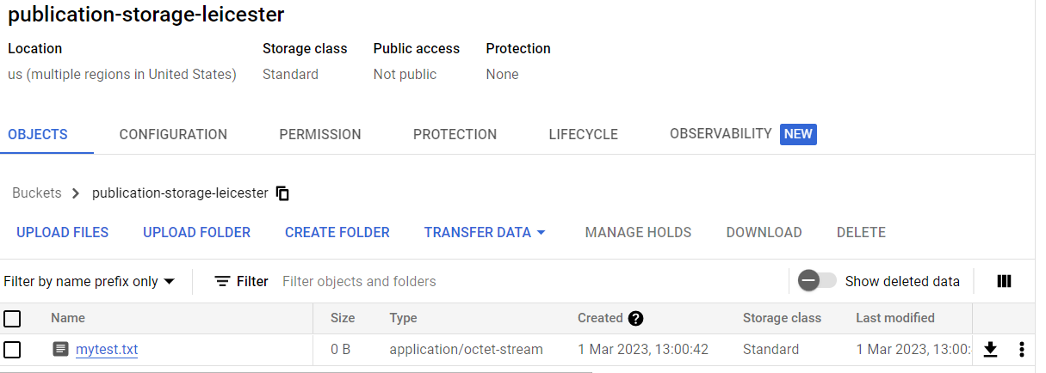

And information about the file will be stored in the Database:

